Deep Learning
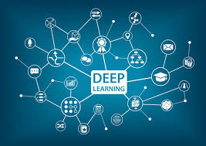
Deep learning is a branch of __________________________________________________ that focuses on teaching computers to _______________________________________. It uses structures called _____________________________________________________, which are inspired by the way the human brain works. These networks consist of ___________________________________ that ____________________________________.
In a deep learning model, the first layers usually identify _______________________ , while deeper layers learn more ______________________________________________ . This process allows the system to make ______________________________________.
Deep learning is widely used in various ________________________________________, such as ___________________________________________ . It has become essential in technologies like ___________________________________________________________ .
Nevertheless, deep learning models require large amounts of ____________________________ and strong ______________________________ to train effectively. Despite these challenges, deep learning continues to _________________________________________ rapidly and plays a key role in modern ___________________________________________________________ systems.
Multilayer Networks
Multilayer networks are an advanced concept in network science ___________________________________________________________________________. Unlike traditional networks, where all connections are treated equally, ______________________________________________________________________. For example, in a social network, ________________________________________________.
Each layer in a multilayer network can _____________________________________________________________________. These nodes can ____________________________________________________. This structure allows researchers to _____________________________________________________.
Write a short essay (100 words minimum) using the words below:
tools – technology – skills – learning – big data – data mining – thus - moreover

__________________________________________________________________________________________________________________________________________________________________________________________________________________________________________________________________________________________________________________________________________________________________________________________________________________________________________________________________________________________________________________________________________________________________________________________________________________________________________________________________________________________________________________________________________________________________________________________________

